**TEMPLATES IN C++:**

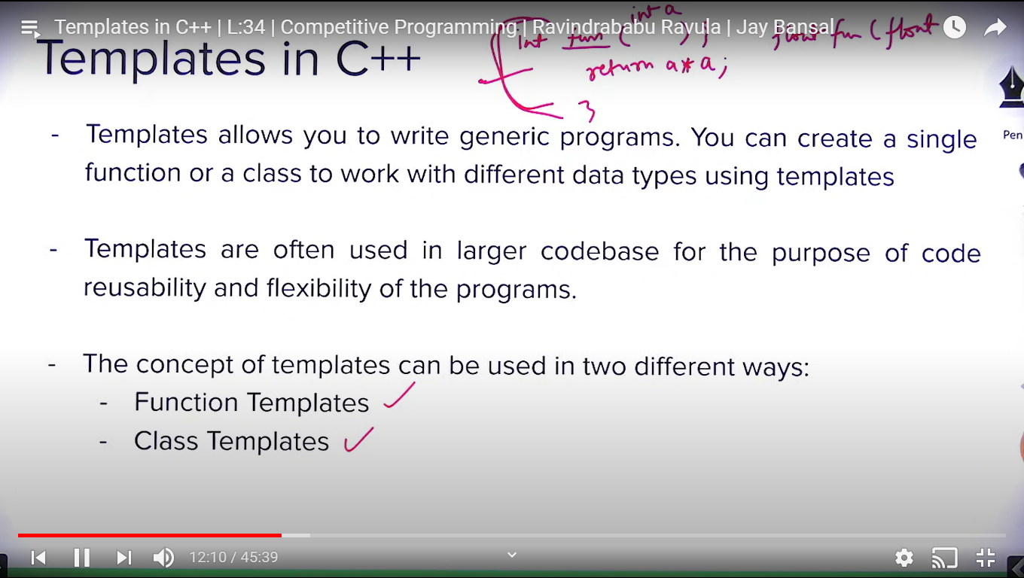

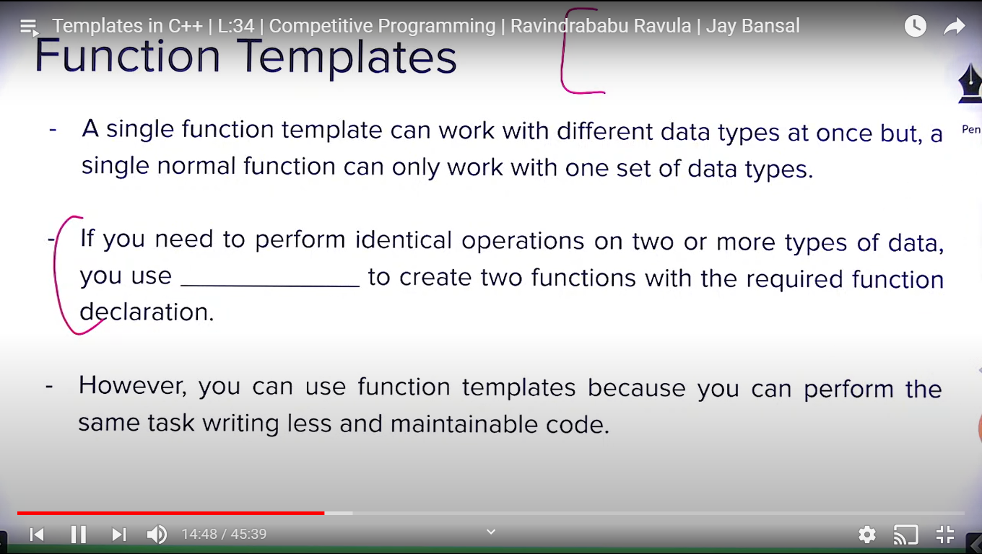

**Ans of blank :** Function Overloading

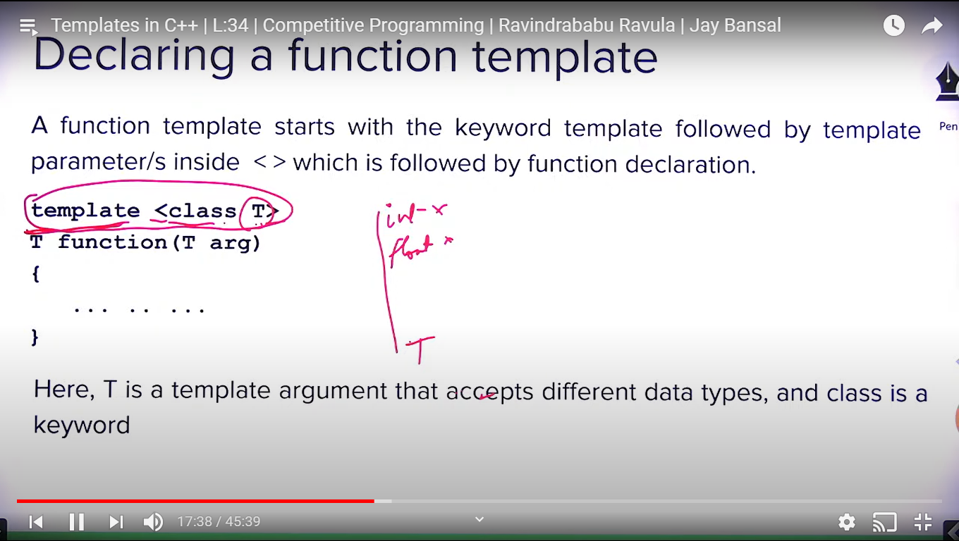

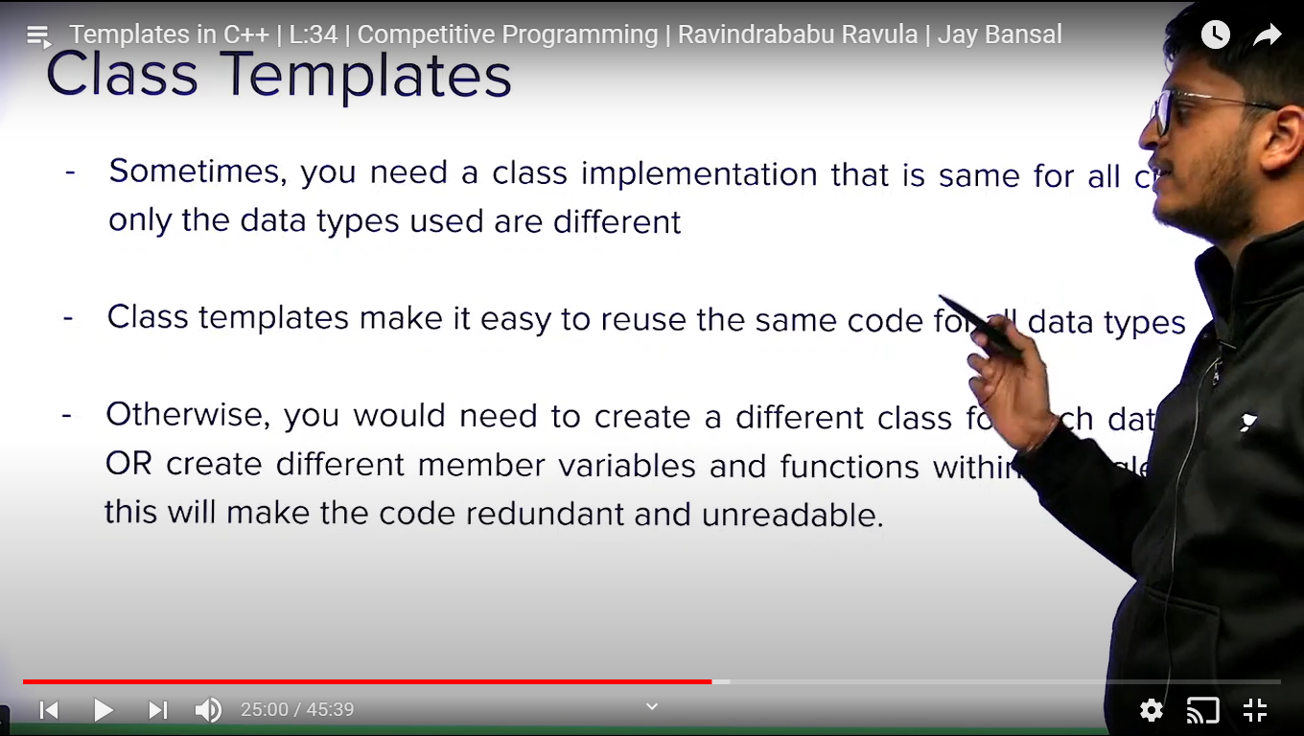

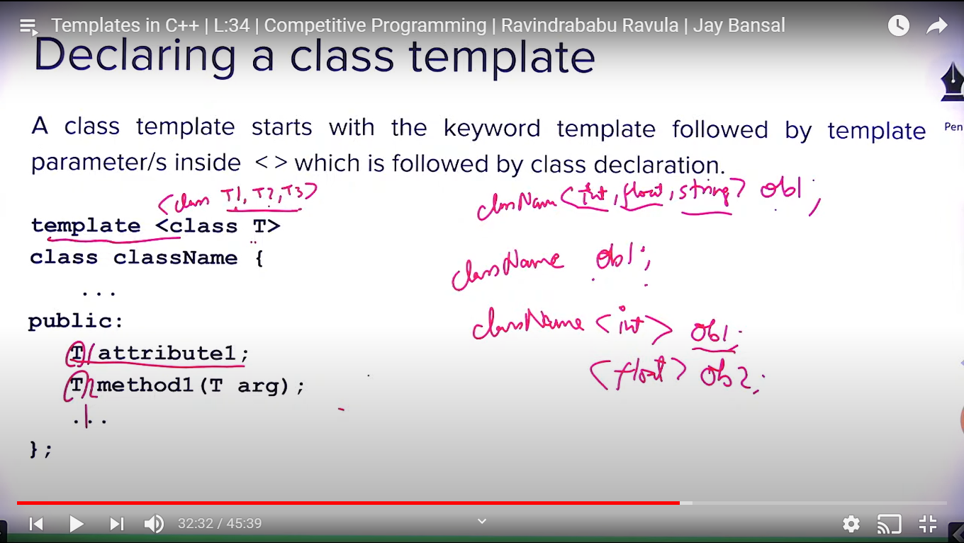

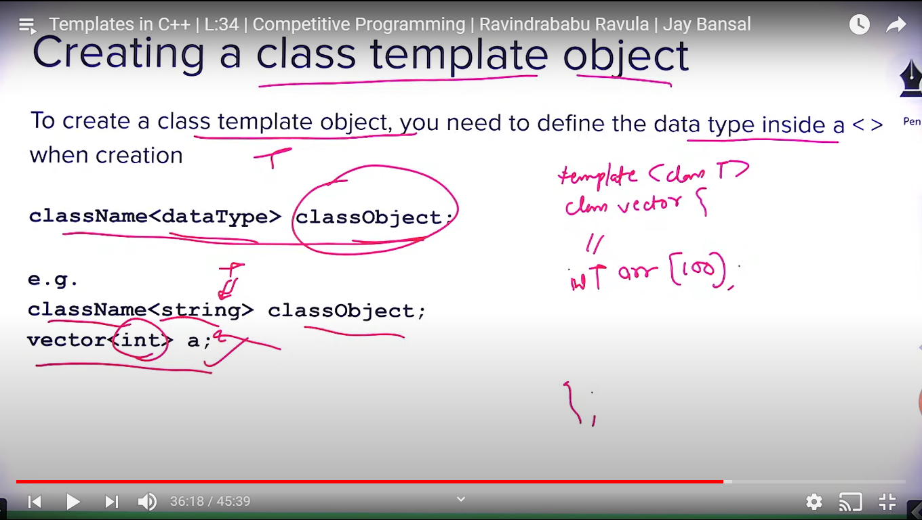

**C++ STL:**

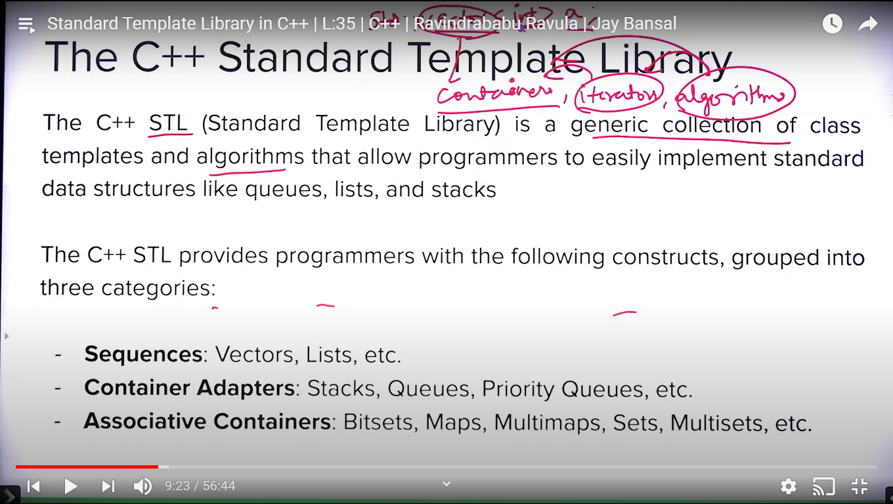

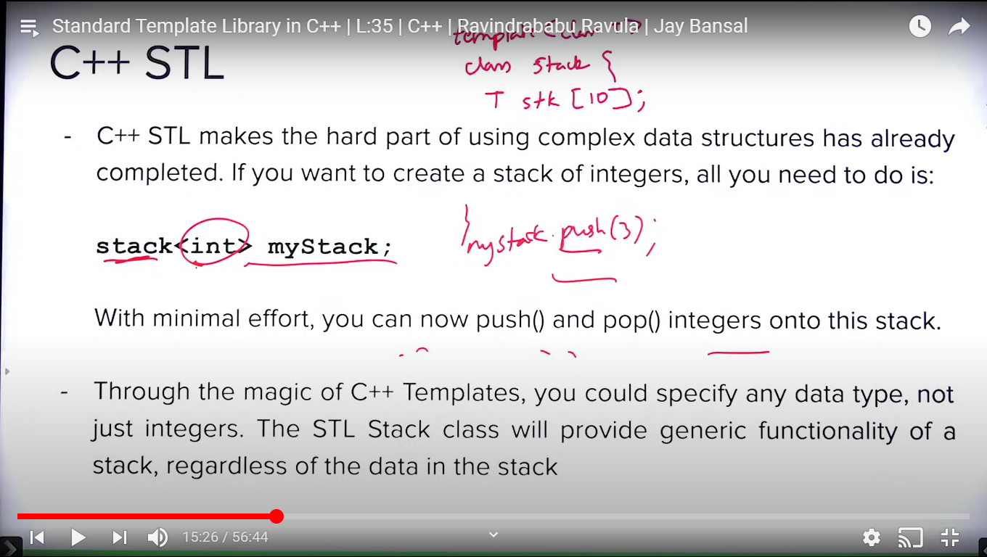

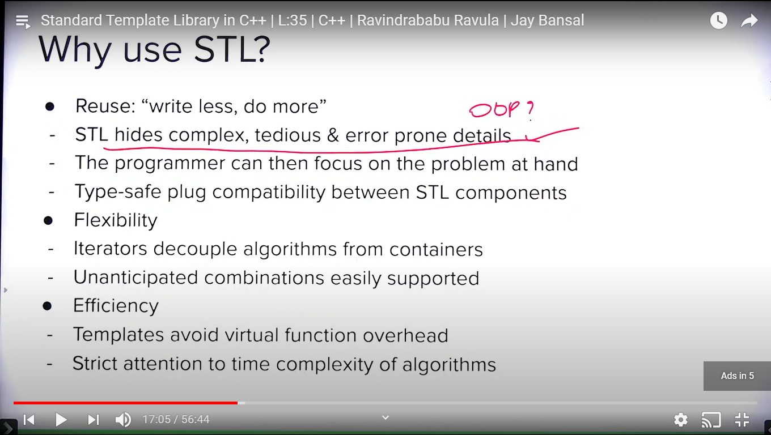

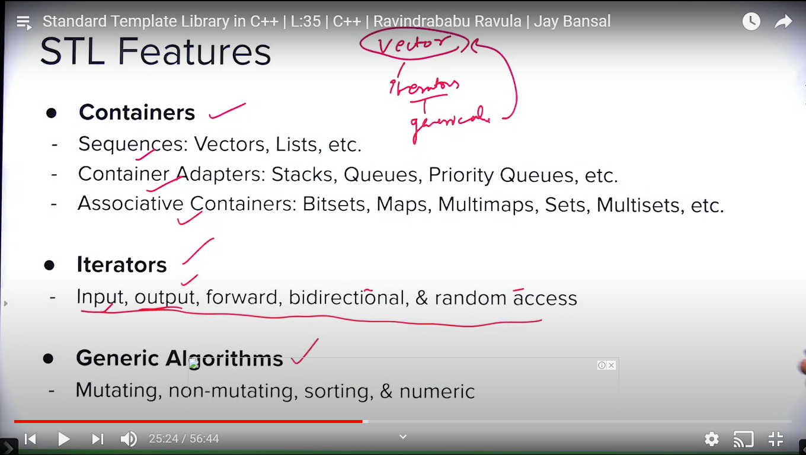

Input iterator is used to store inside or push element in container.

Output iterator is sused to extract data from container.

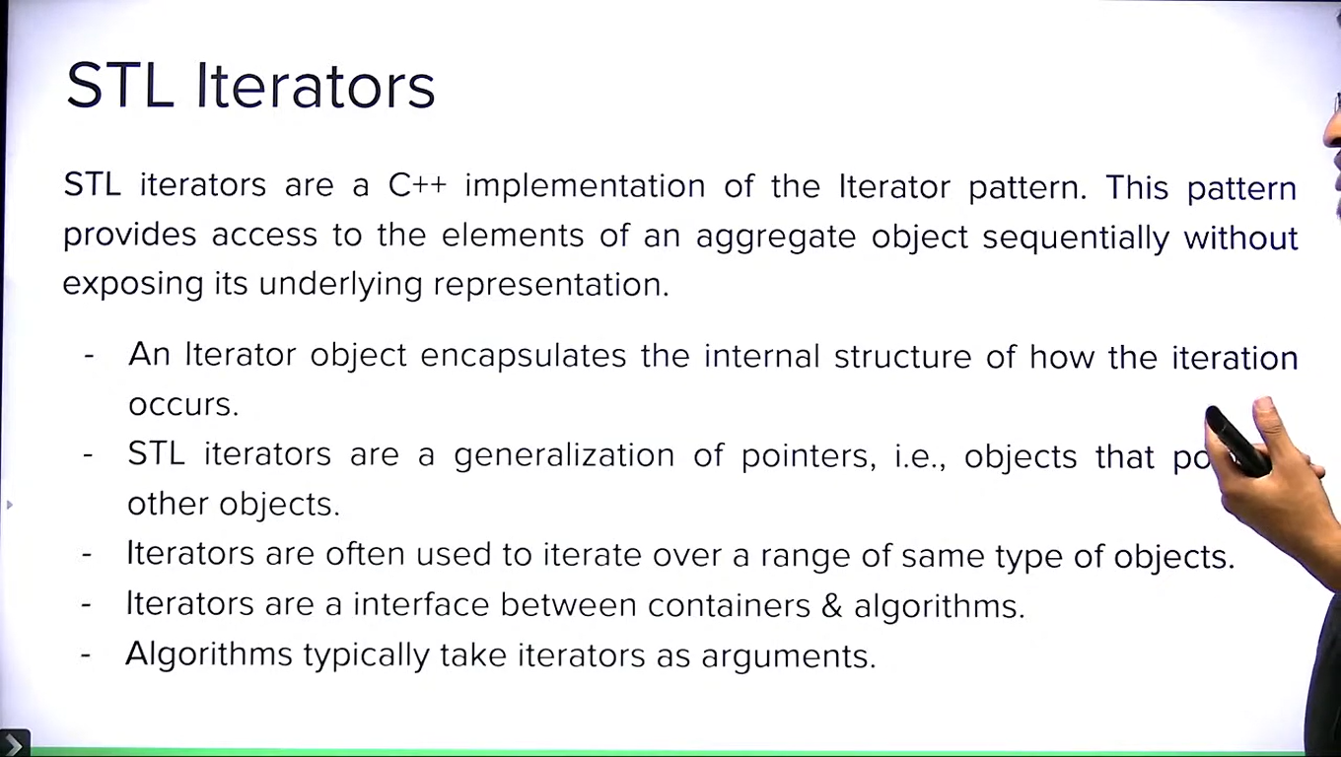

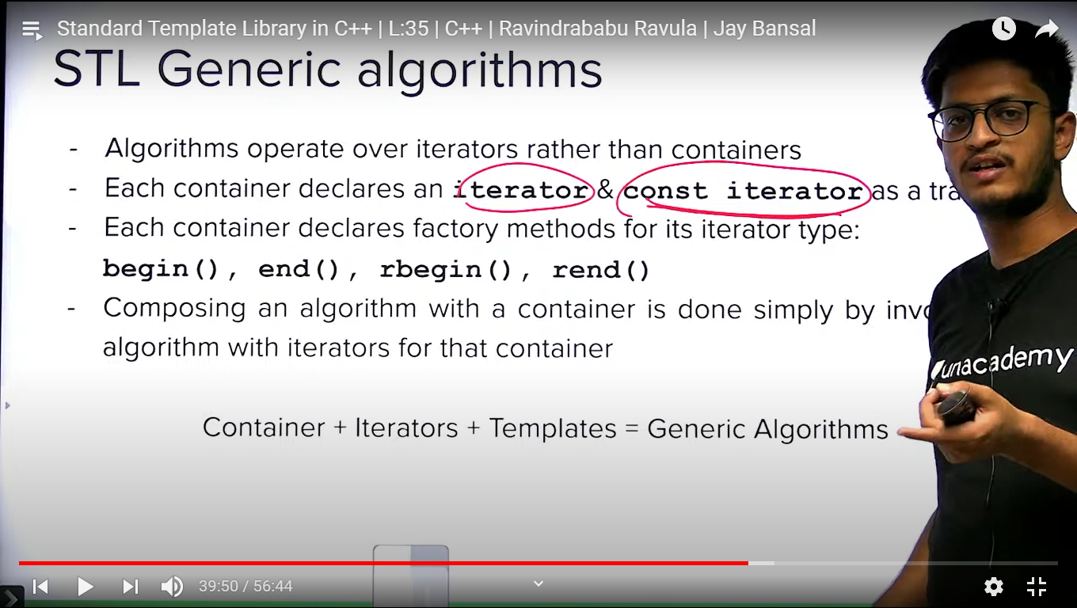

**VECTOR:**

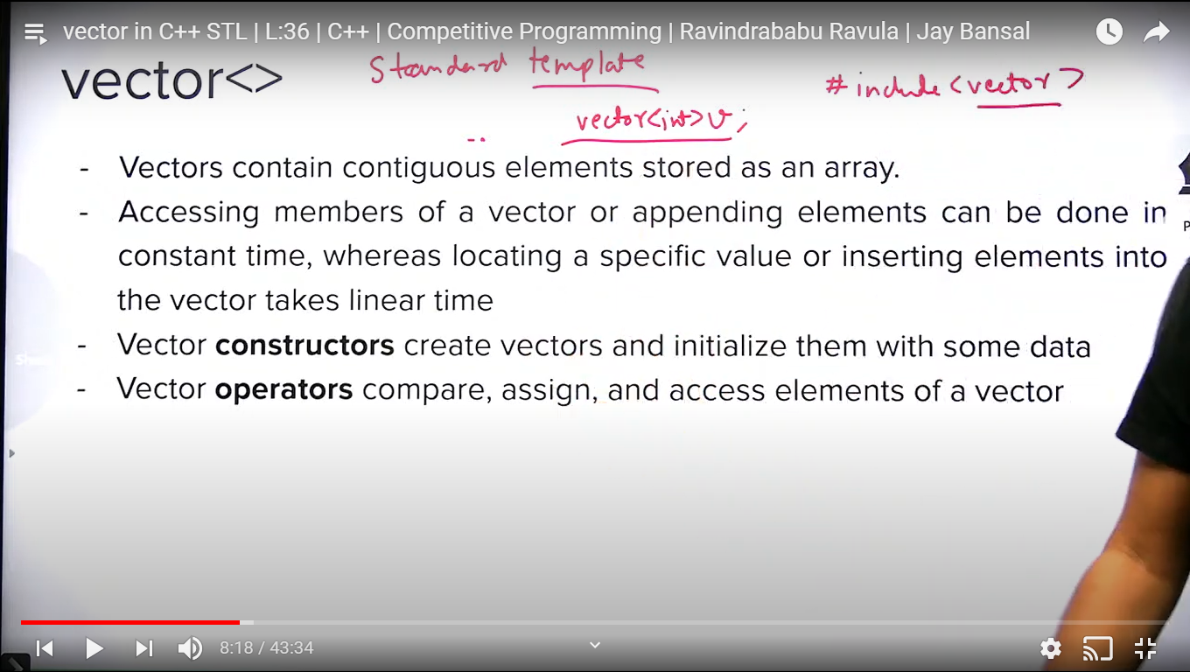

V1 == v2 // compares two vectors, == operator is iverloaded

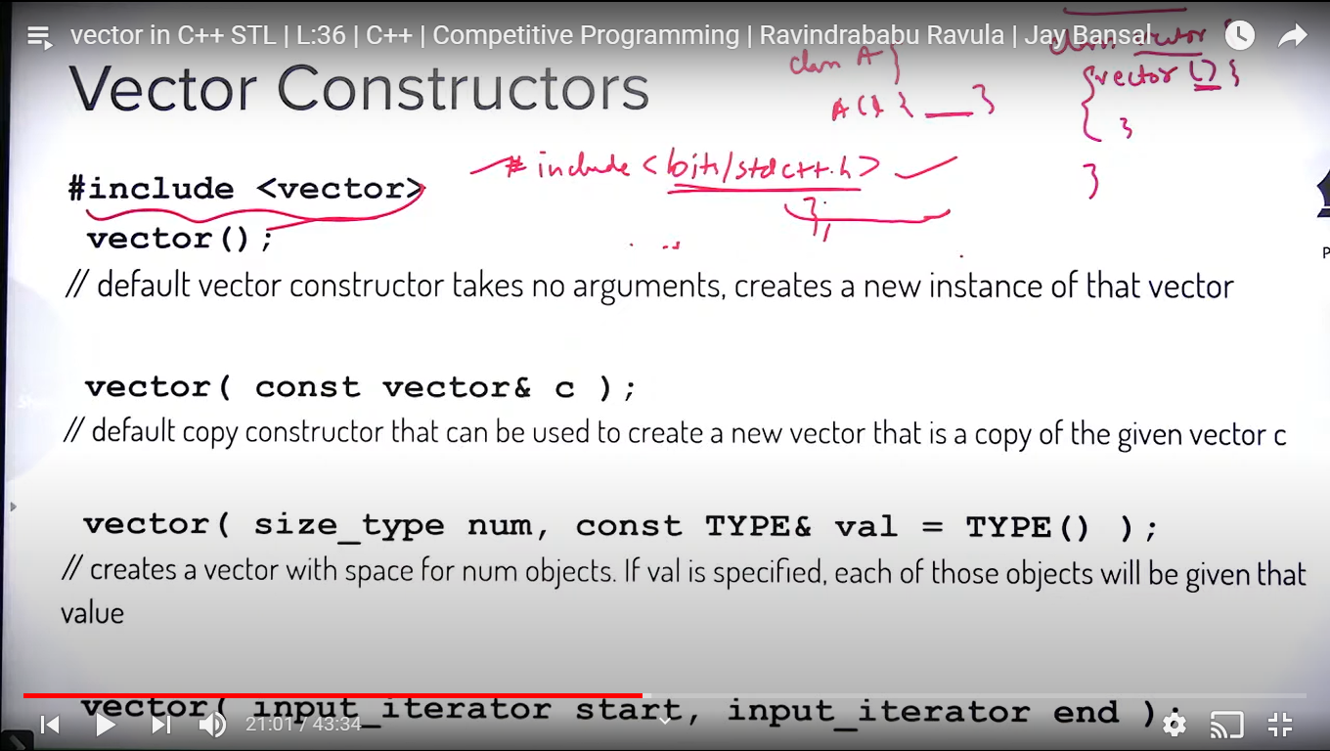

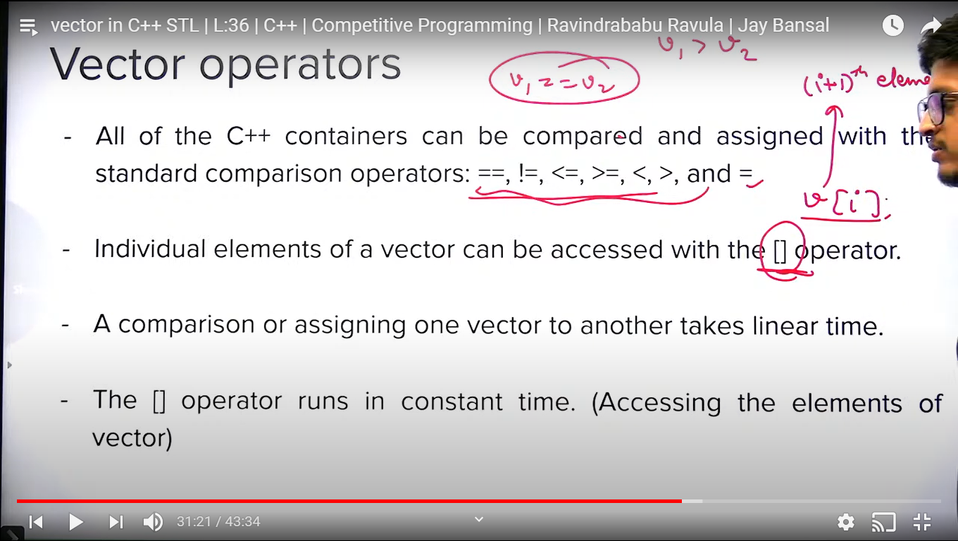

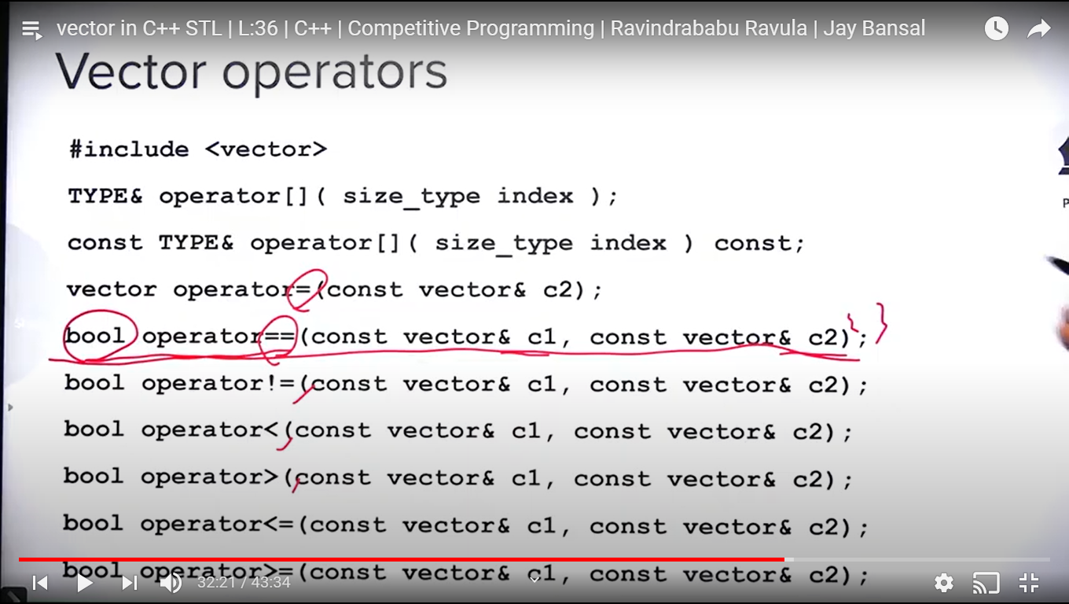

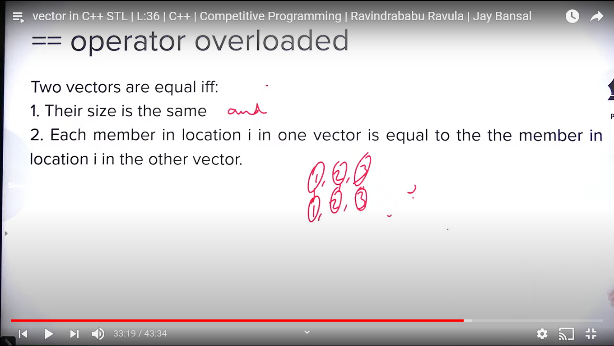

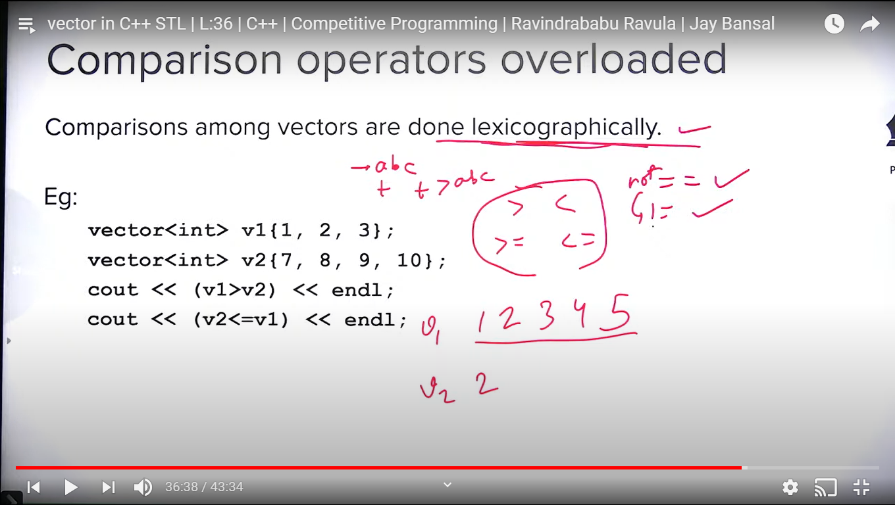

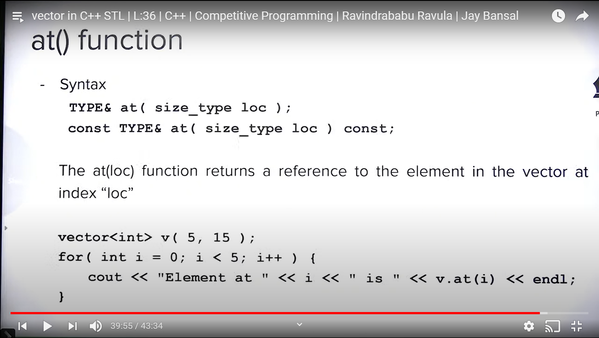

At() function checks out of bound index internally but [] overloaded operator does not.

A() throws exception in case of out of bound index access.

[] will give illegal value or make the program crash in case of out of bound index access.

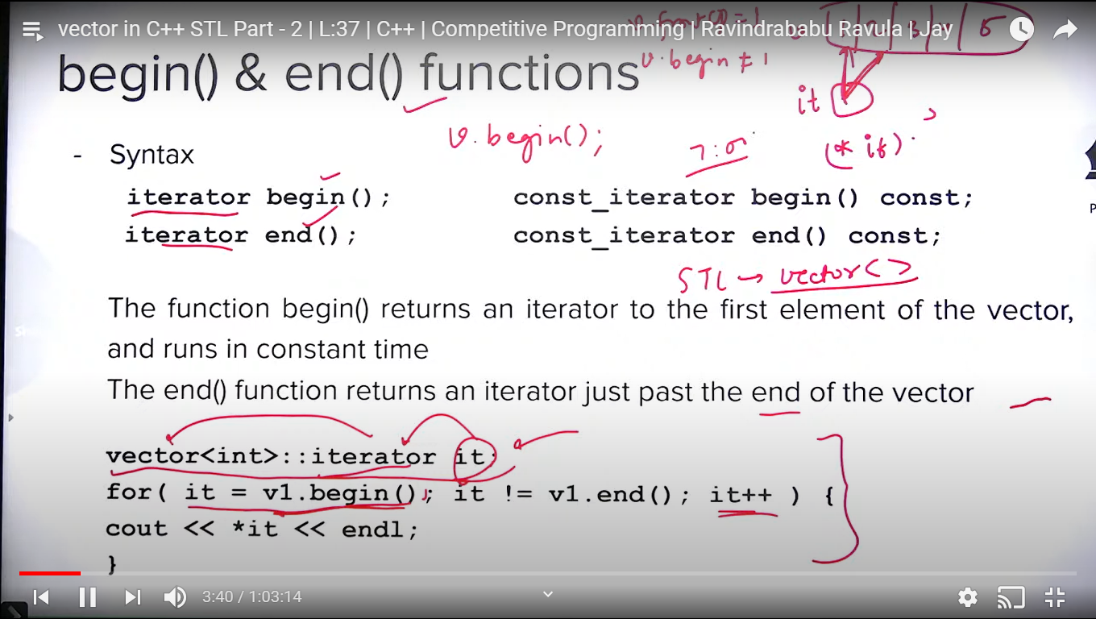

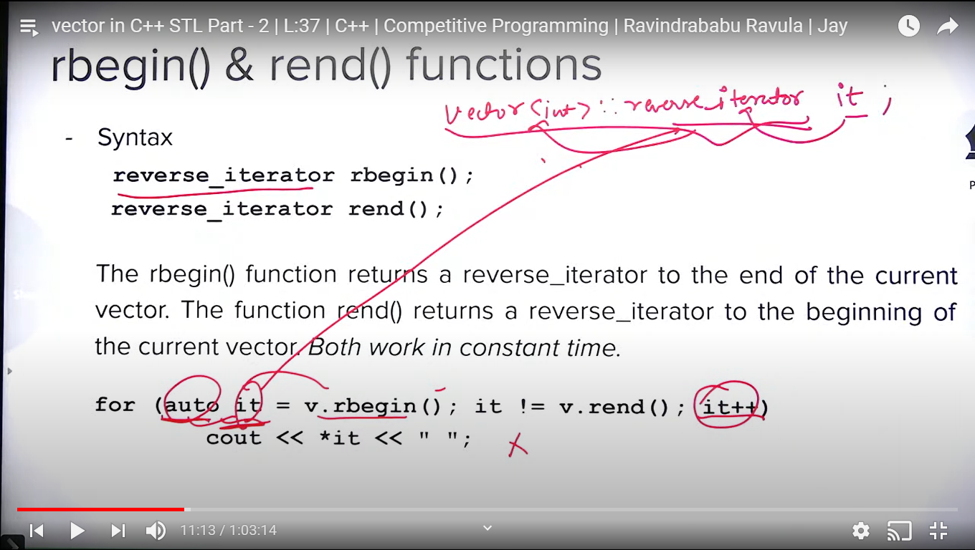

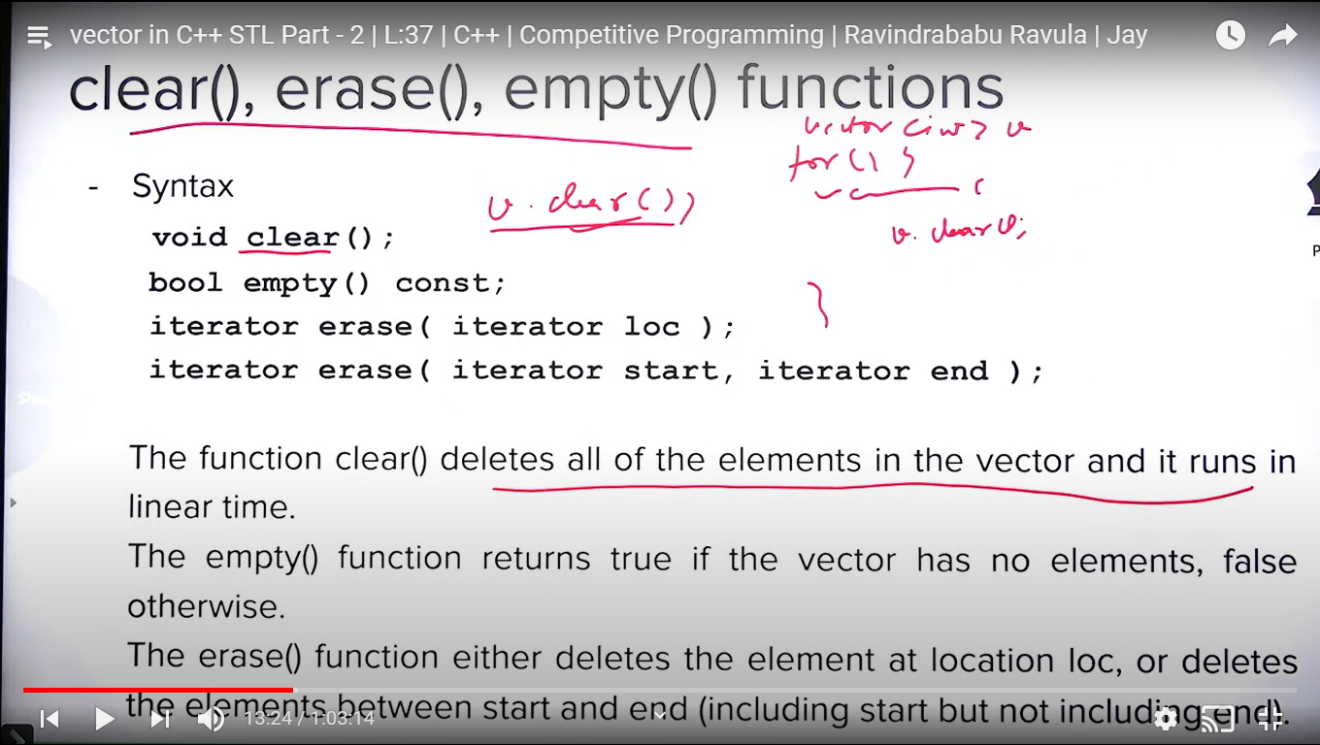

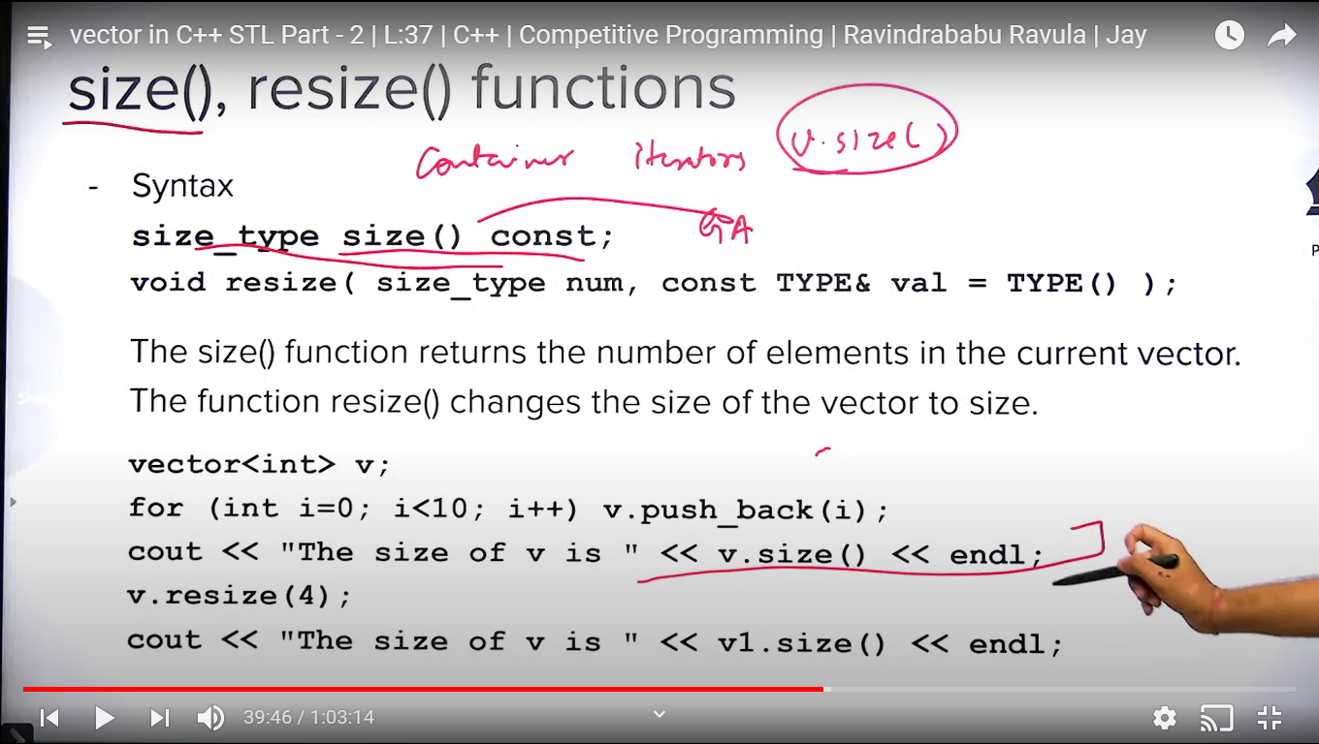

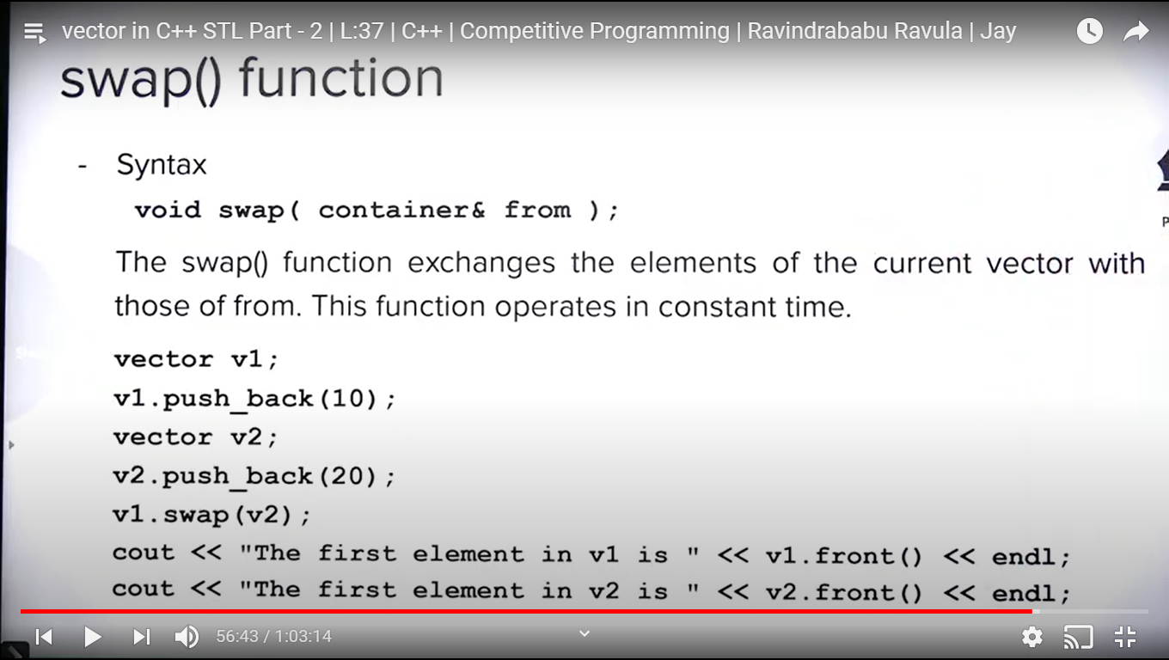

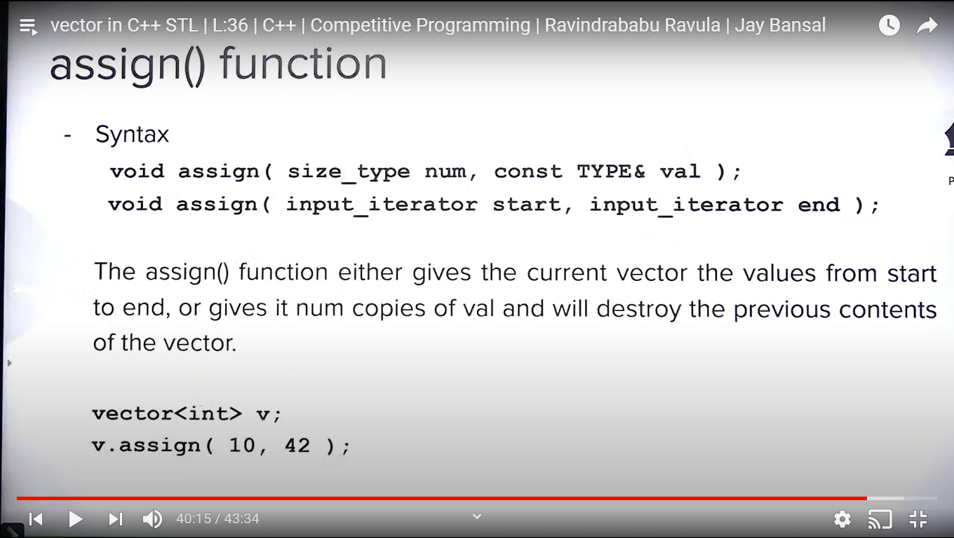

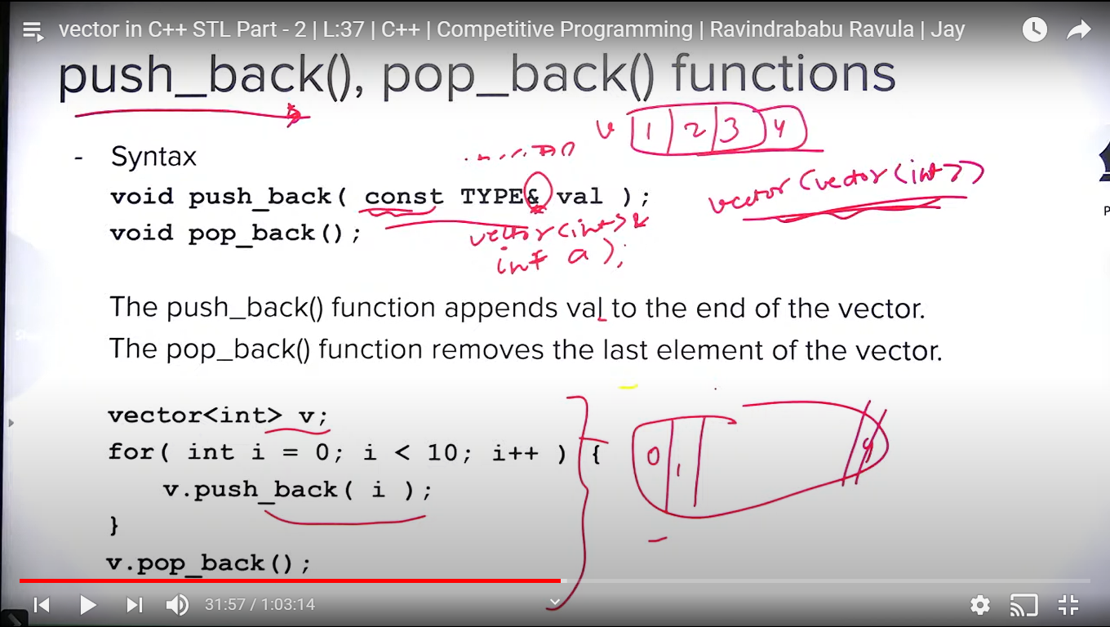

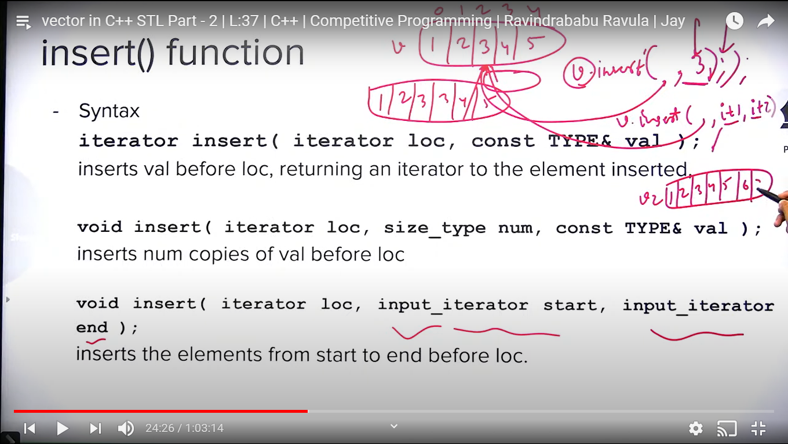

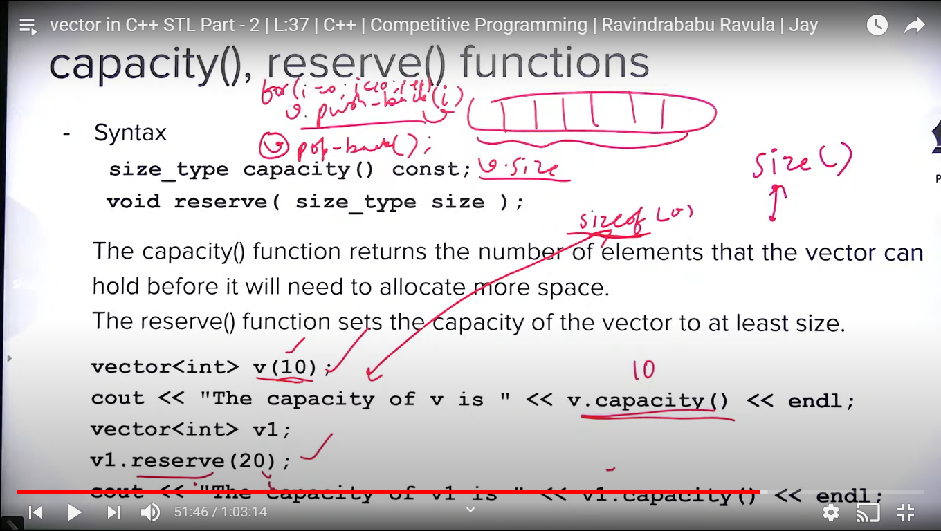

**ITERATORS IN C++ STL:**

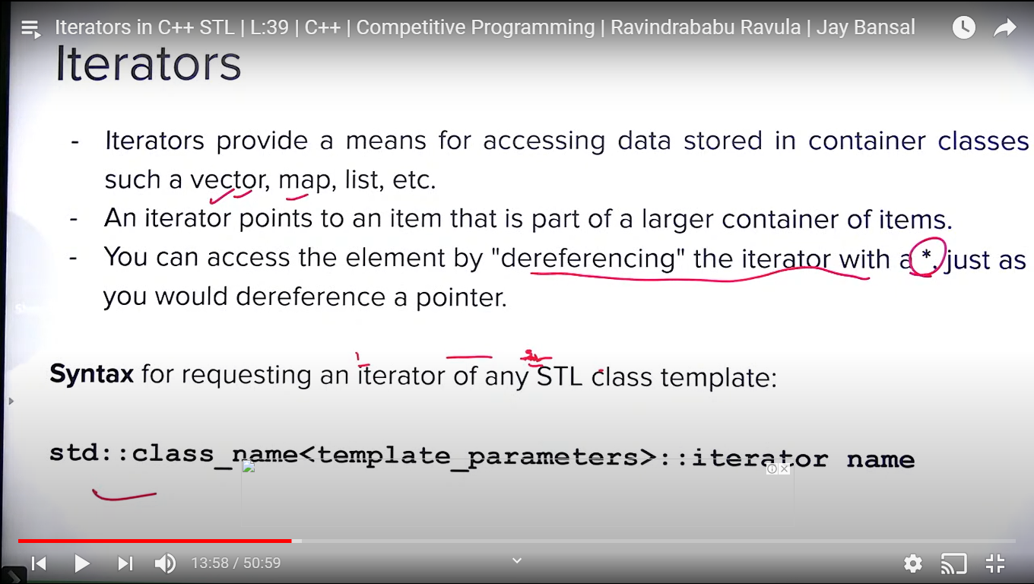

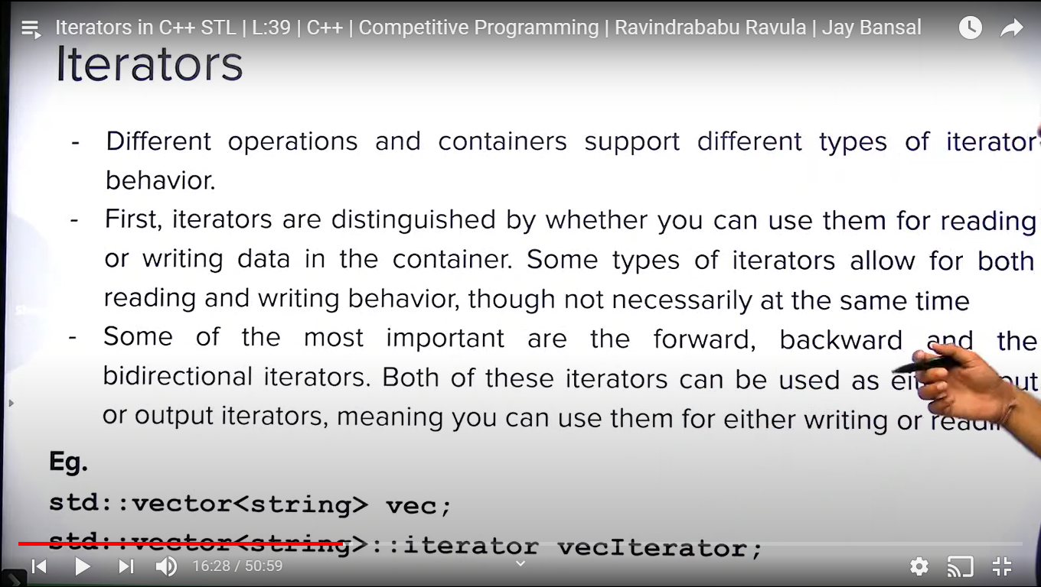

Std::vector<string>::iterator vectIterator; // this kind of iterator are used as input and output iterator both.

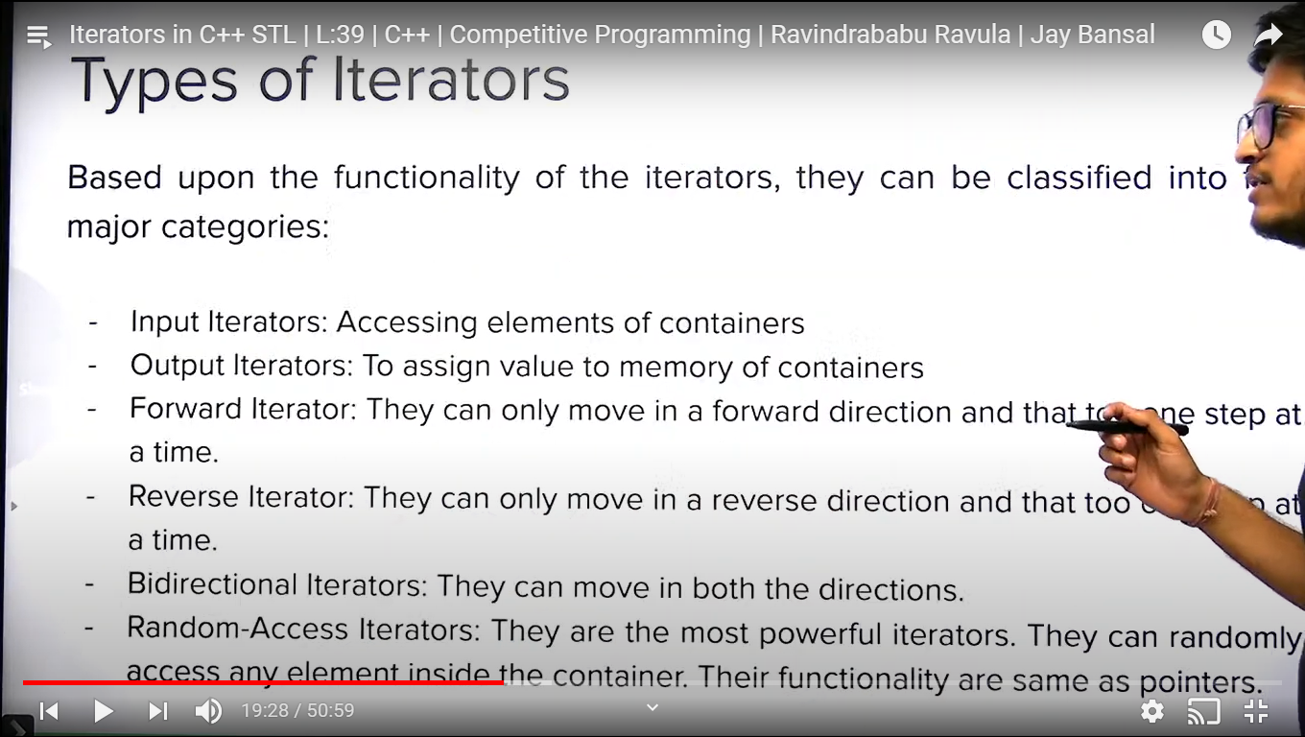

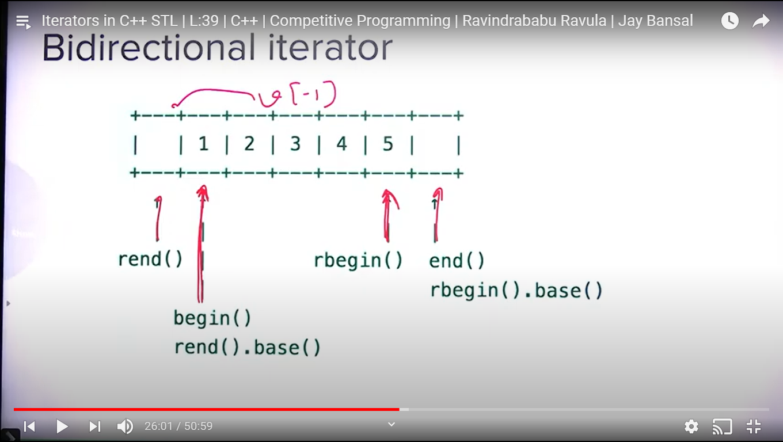

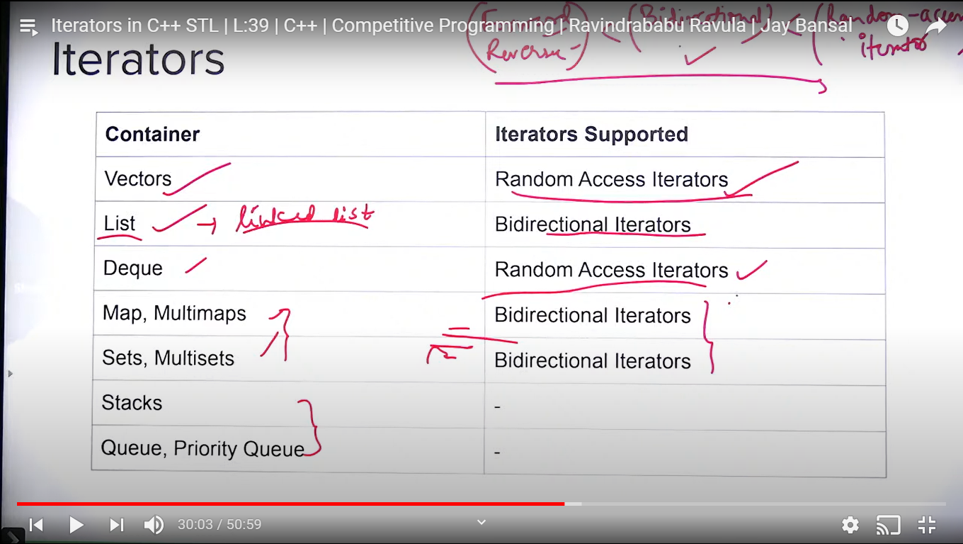

Stack, Queue and Priority Queue doesn’t support iterators.

Algorithm is based on iterator. We cant perform any algorithm ex (sort, search etc) on stack and queue because they don’t have iterator.

If any algorithm needs random access iterator, we can apply that algo on vector or dequeue.

If any algo needs bidirectional iterator , we can apply that on list, set, multiset etc..

It = it + 2 // possible with random access operator only.

Forward, backward and bidirectional operator supports it++, it—only.

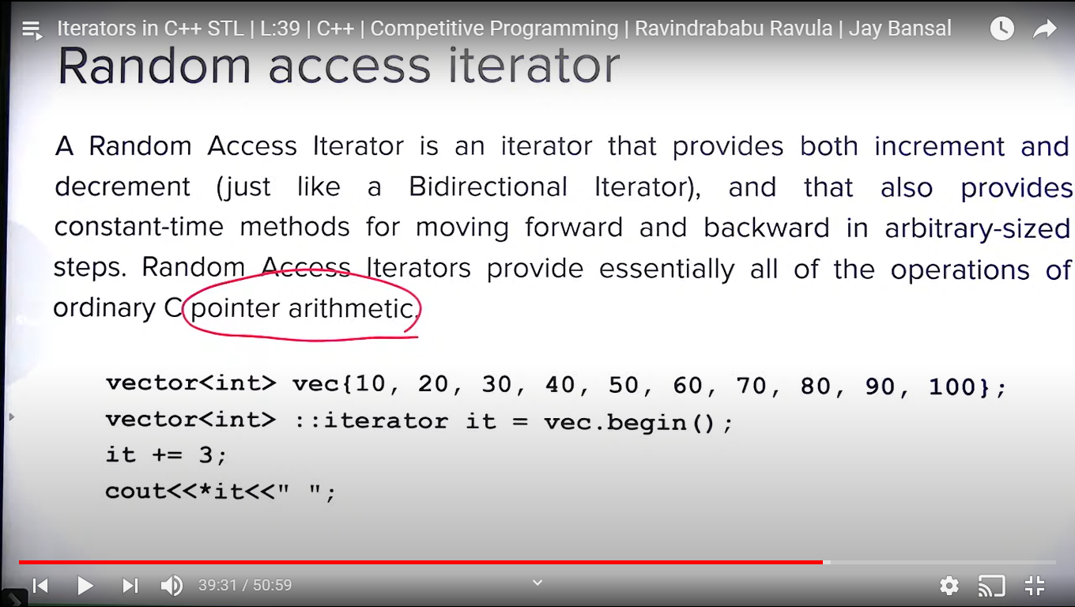

**Note:** *(it+i) is allowed only with random access operator.

Arithmetic operation cane be done only on random access iterator. Ex : ( it1 – it2 ) or ( it1 + it2) etc.

**sort(), sort_heap, stable_sort()**

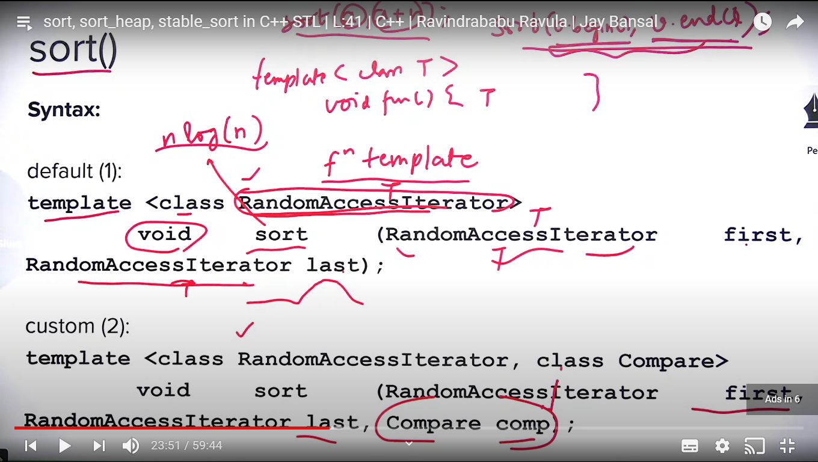

**Note:** sort() uses random access iterator.

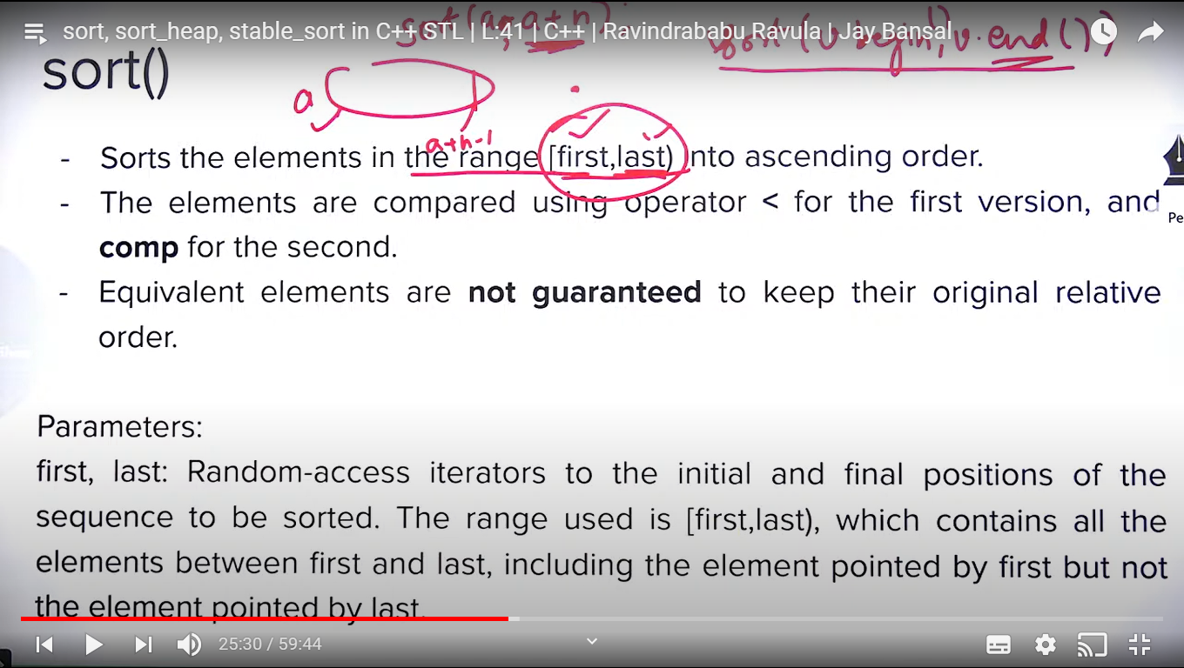

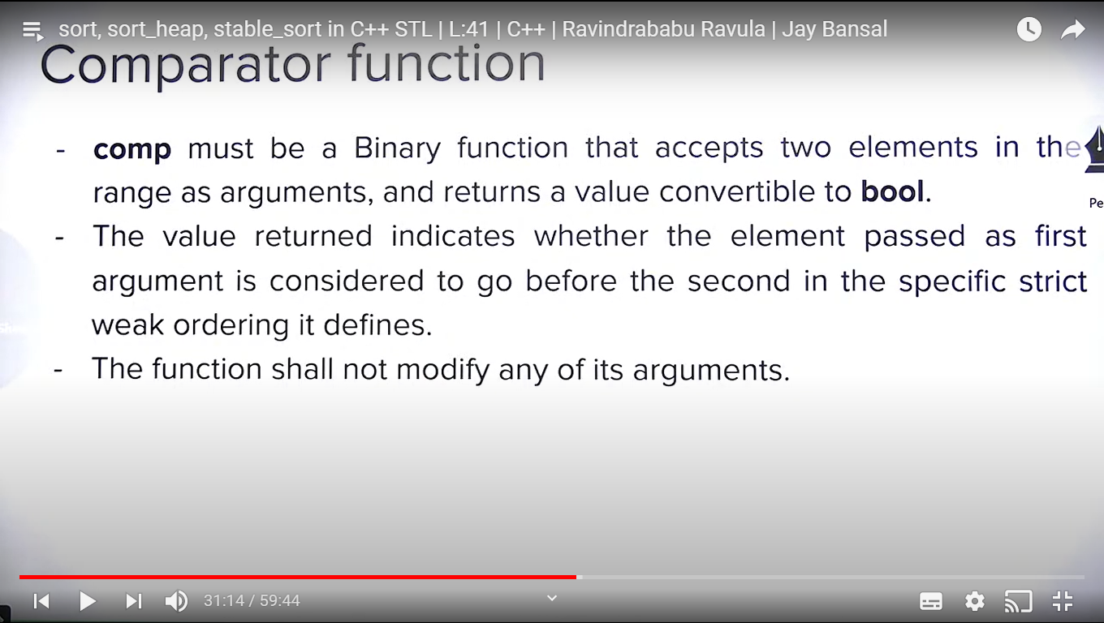

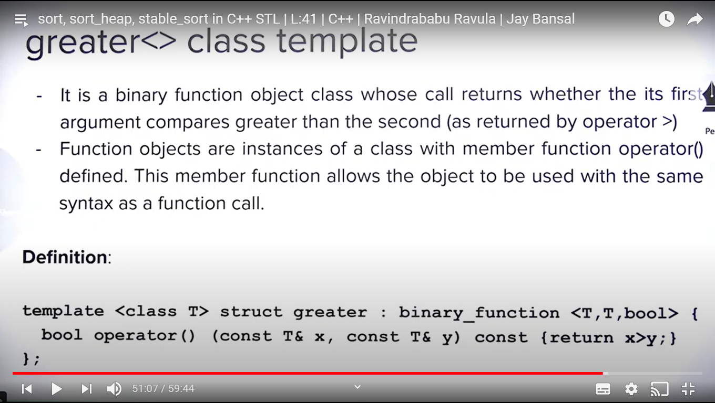

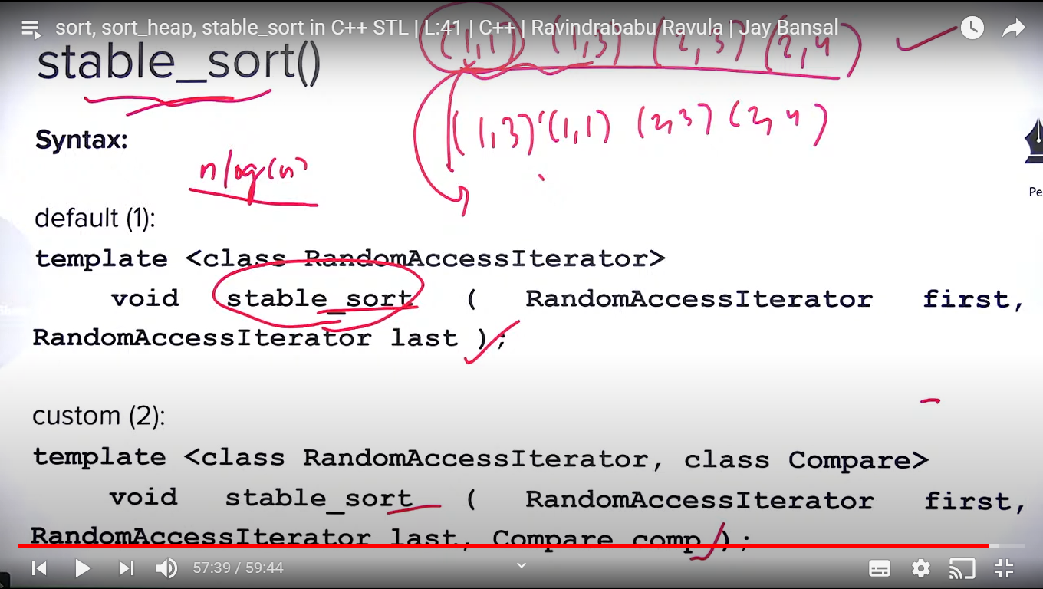

Stable_sort() is useful when you have vector of vector, vector of pair, vector of triplets etc..

**Binary_search(), upper_bound(), lower_bound()**

These functions requires the container sorted.

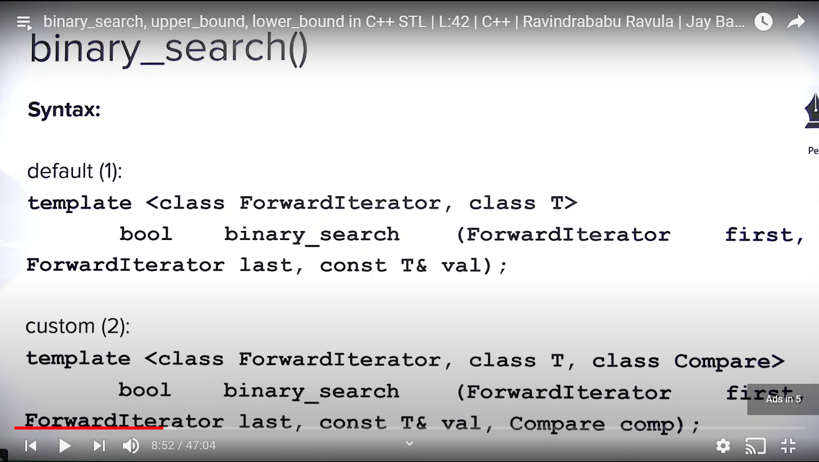

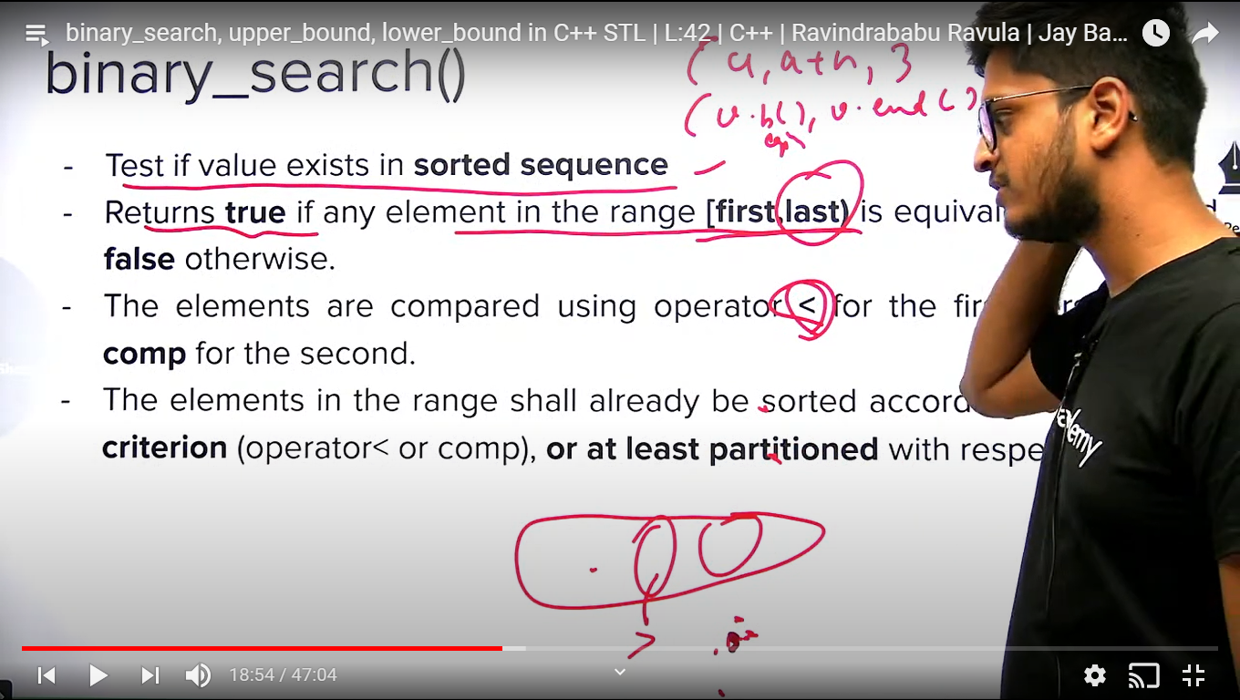

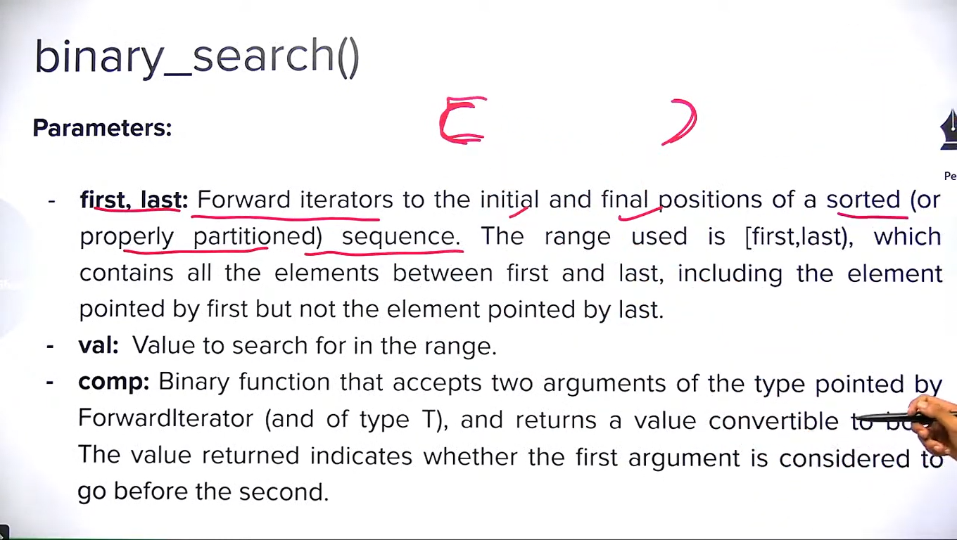

**Note:** If container is sorted using any comparator function, we need to provide same comparator function while binary_search.

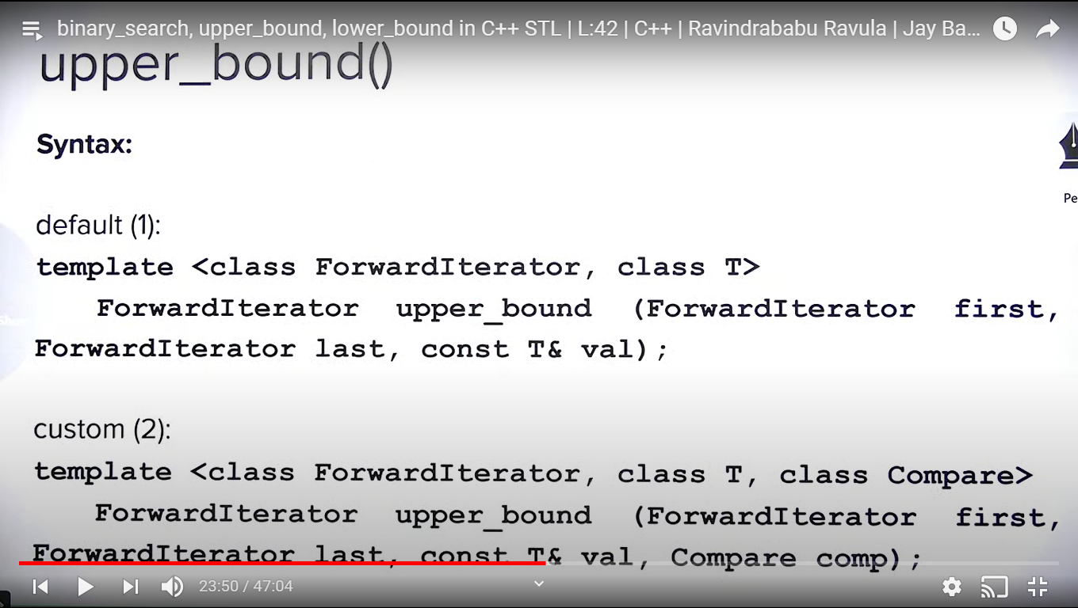

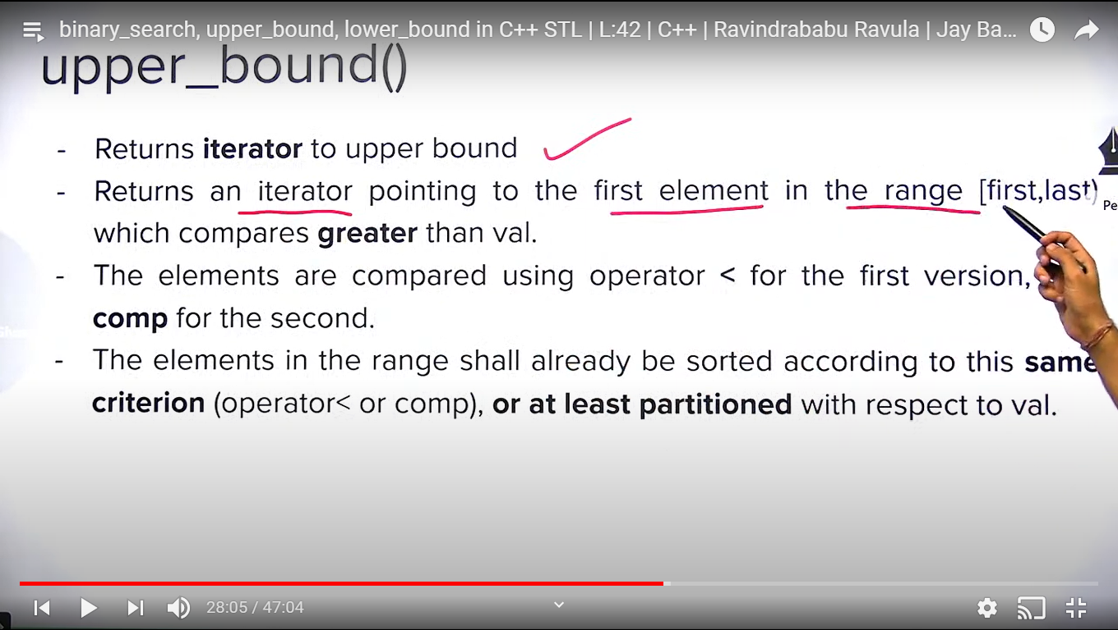

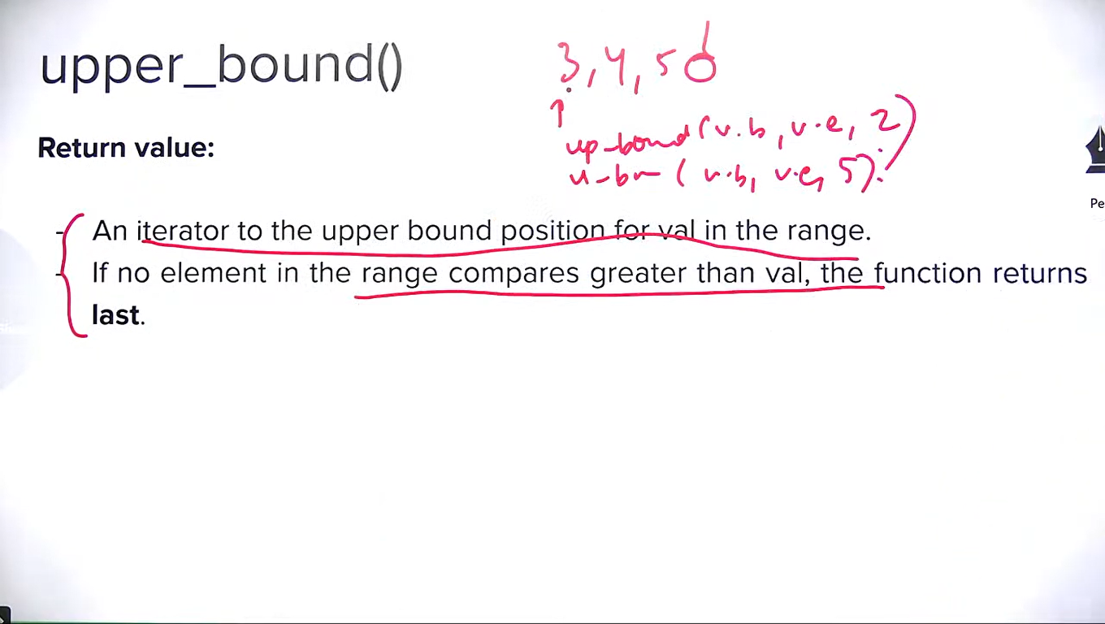

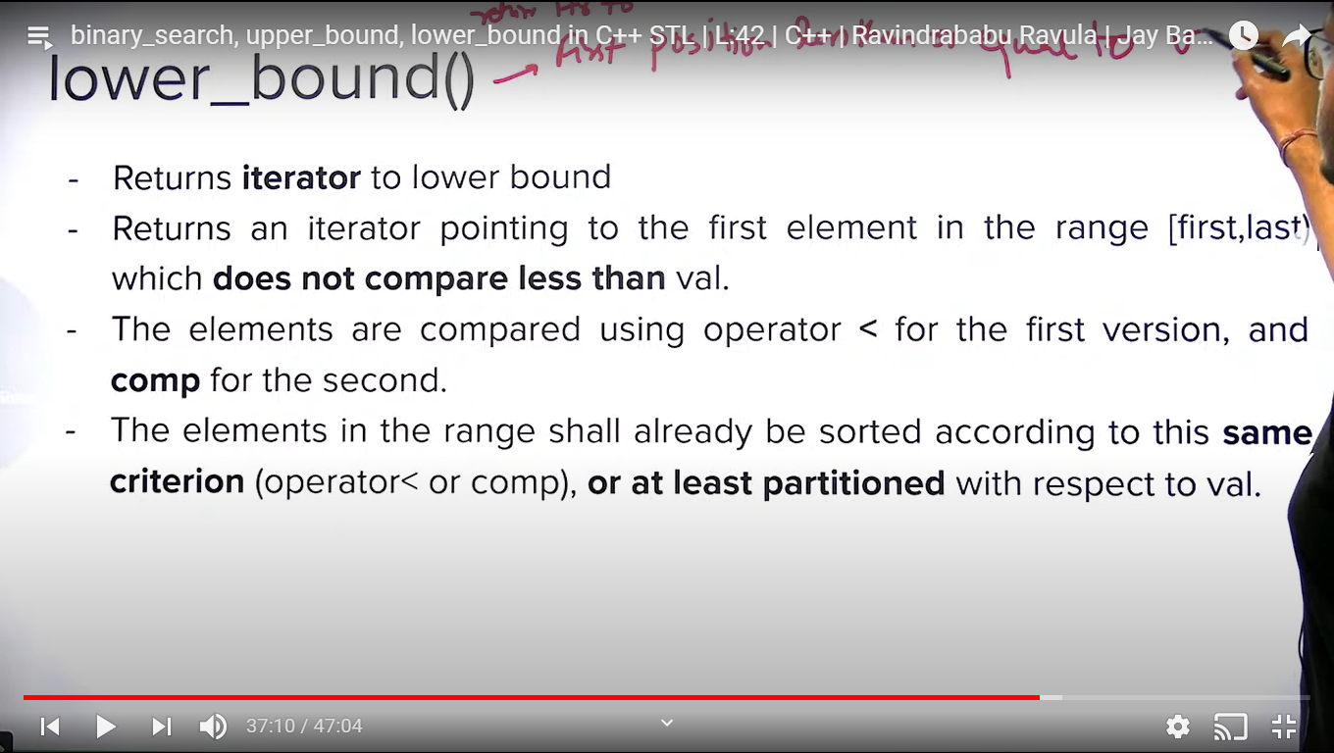

**Note:** returns iterator pointing to the first element in the range [first, last) which is greater or equal to the val.

**Note:** lower_bound() and upper_bound() of an element can be same if the value is not present. Think of this.

